.

Technology
Digital
Year 5
Assignment 1

Student Name:
Class Teacher Name:
Year Level:

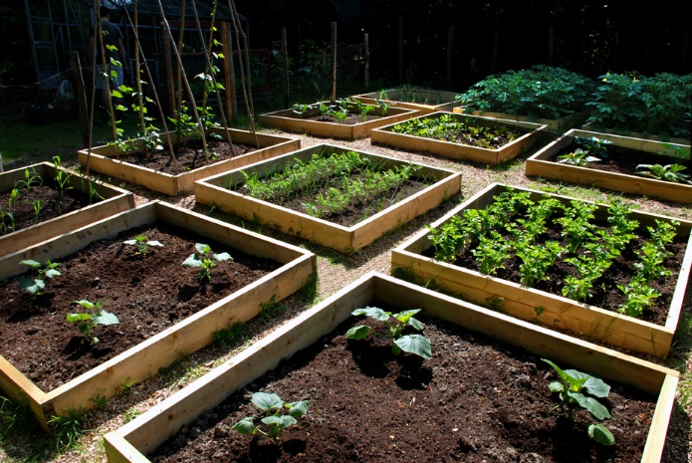
Students will be required to participate in observations and maintenance of a vegetable garden in the school, where they will be given certain areas to monitor, nurture and record results. These observations and monitoring will involve students testing growth, soil quality, dew point and how much water they have used on their section of the garden when watering the vegetables. Students will then be required to input this information electronically on a spreadsheet where they can maintain records daily as well as a weekly. Students will then participate in an online collaborative session each week and communicate with each other on a forum and express their observations and the data they have entered in the spreadsheets. Students will present a minimum of 2 questions to the person they are communicating with about their data and weekly results. This assessment item links heavily with the Australian curriculum and is closely related to the following descriptors and elaborations. Acquire, store and validate different types of data, and use a range of software to interpret and visualise data to create information. The Elaboration will be, using digital systems to validate data, for example setting data types in a spreadsheet to make sure a date is input correctly. The other descriptor is plan, create and communicate ideas and information, including collaboratively online, applying agreed ethical, social and technical protocols. The following elaboration will be used, using a range of communication tools to share ideas and information, for example participating in collaborative online environments. This assessment piece also allows students to apply the general capabilities of numeracy, critical and creative thinking as well as the cross curriculum priority of sustainability. This assessment Item is relevant and will draw on computational thinking and skills to be most effective for knowledge acquisition.

Grade | A | B | C | D
Knowledge and understanding of applying correct techniques and methods to extract and validate the appropriate data. | Superb display of knowledge and understanding and is precise with obtaining and validating data and using correct techniques. | Knowledge and understanding is appropriate. Techniques and methods meet requirements with only minor errors in extracting and validating the data. Data is extracted with minor errors. | Knowledge and understanding is evident however the application of techniques is satisfactory and has errors. Data is extracted with errors and cannot be validated appropriately. | No or very little knowledge and understanding of how to extract and validate data. No attempt to extract data for the next phase of the assessment.
Application of appropriate knowledge, skills and methods to input data into a spreadsheet and keep track of it using correct formulas. Data is accessible and is viewable in a sustainable way. | Clear acquisition of knowledge, skills and methods and are applied effectively to keep record of data in a spreadsheet. Correct formulas are used and spreadsheets are easily accessible. Can be viewed in a sustainable manner with all data and formulas demonstrated. | Knowledge, skills and methods have been applied with minor errors in the data input. Formulas are evident with minor errors and data is accessible. The majority of the spreadsheet can be viewed without printing. | Knowledge, skills and methods are evident but are applied satisfactorily. Formulas have errors and data is not clear as a result. Spreadsheets are accessible and not all factors of the spreadsheet can be viewed without printing. | No or very little knowledge, skills and methods applied to the input of data. No or very little data is evident. Data is not accessible and needs to be printed to view.
Participation in online discussions and forums. Questions are on topic and are able to draw appropriate knowledge. Two questions have been presented to the other person. | Adequate participation is clearly evident in discussions and forums. All questions are suitable and are clearly drawing knowledge from the recipient. Two or more questions have been posed. | Appropriate participation in online discussions and forums. Questions are on topic and draw on majority of knowledge, not all. Two questions have been posed. | Participation is evident but minimal in online discussions and forums. Questions are very basic and draw on very little knowledge. Two questions have been presented and on occasions only one question is evident. | No sufficient evidence of participation in online discussions
Applying knowledge learnt to effectively answer questions posed. Informative, clear and concise answers are evident and provide the communicator with a sufficient answer. | Knowledge is clearly evident and all questions have been answered appropriately and effectively drawing on knowledge learnt. All answers are extremely clear and concise and give the communicator an answer that is detailed and informative. | Knowledge is applied in answering the questions. Answers are clear and concise but leave minor details out to be a fully informative answer. Answers provide the communicator with some idea of what data has been explored. | Satisfactory application of knowledge to answer questions. Answers are unclear and disjointed and provide the communicator with some knowledge in their answer. | No questions answered online and no knowledge acquisition shown.

